**Module 3: Building Corporate Culture**

**Task 1: Aptitude Test**

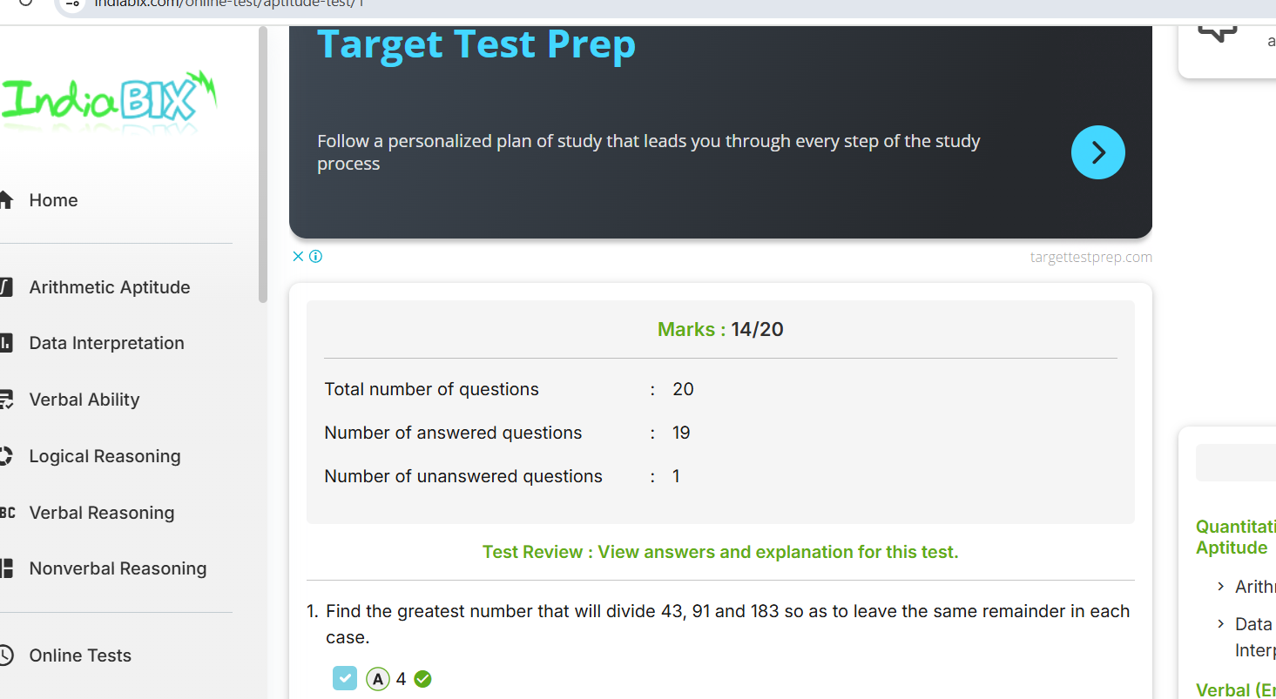

**Task 2: Presentation / Self Elevator pitch Video**

**Link :** [**https://drive.google.com/file/d/1-zk7eggWr5fiMrVUwdEMB9Pdt7J3pqem/view?usp=drive_link**](https://drive.google.com/file/d/1-zk7eggWr5fiMrVUwdEMB9Pdt7J3pqem/view?usp=drive_link)